

SECJ2203 SOFTWARE ENGINEERING

PROJECT PROPOSAL

EVENT MANAGEMENT SYSTEM FOR K01,
KOLEJ TUN RAZAK

18th APRIL 2024

FACULTY OF COMPUTING

PREPARED BY:

GROUP MEMBERS | MATRIC NUMBER
VENNISE NGOH YAN LENG | B23CS8032
ARIEF NAJMI BIN BAKIYUDIN | A23CS8004
OMAR ABDELMONEM HANAFY | A22EC4012
AINA ZAFIRAH BINTI AHMAD MUZAMIR | A23CS8014
SADIK AL MAHMUD | A20EC4049

TABLE OF CONTENTS

1 INTRODUCTION 3
1.1 THE GOAL 3
1.2 THE SCOPE 4
2 SOFTWARE PROCESS MODEL 5
2.1 THE GOAL 5
2.2 THE CHOSEN SOFTWARE PROCESS MODEL 6
2.3 PROJECT DURATION 7
REFERENCES 9

1 INTRODUCTION
The Event Management System for Kolej Tun Razak is a digital tool that makes it easier for organizers to plan, organize and execute their event in Kolej Tun Razak. It combines a range of features for organizer and administrator such as a request for booking event places with a range of time, buying activities plans from the college and scheduling their event for the organizer. The system includes managing event places, activities, activities package, approve or deny an event request from the administrator. Overall, the Event Management System for Kolej Tun Razak should help reduce the workload for organizing an event for both organizer and administrator of Kolej Tun Razak by providing features for registration, marketing, reporting and analytics and more.

1.1 THE GOAL
An event management system is often needed in college and university campuses where organizing events are always happening all the time. Whether they are organized by students, faculty or outside organizers, there are always a large quantity of events needed to be held each semester. When all of these events take place, it is critical for administrators to have full control for new coming events, renting facilities and separating man force for each event. A lot of events have been declined or postponed due to insufficient planning.

The organizers also find it hard to plan their activities when they cannot check the availability of the event places and facilities offered in each place. In old ways, organizers would need to ask and wait for a long time before they could get to know the availability of the palace and facilities, and if they wanted to change their times for their events, it would be more complex work because they need to start their planning and repeat the steps all over again. The administrators will find it hard to acknowledge and track how many events are running and what are the needs for each event.

Hence, the primary goal of the Event Management System for Kolej Tun Razak is to facilitate the planning, execution, and evaluation of events in a way that maximizes efficiency, effectiveness, and participant satisfaction. The administrators of Kolej Tun Razak need a system which will help to sort out all availability places, facilities, event schedule and make an event report to reduce their workload and human error while managing the event. The objectives of this project includes:

- To provide a tool that can help reduce the workload for organizing an event for both organizer and administrator of Kolej Tun Razak.
- To streamline the event planning process to make it more efficient and less time-consuming for organizers.
- To collect data before, during and after an event to analyze performance of the system, gather feedback, and make informed decisions for future events.

1.2 THE SCOPE
The scope for the Event Management System for Kolej Tun Razak varies on specifics needs and requirements of the users. This system shall be designed as a responsible website which is easy to access by all users with different devices, and running all the time due to most of the students being busy at the office hour because of study. Administrators should have their own website that can manage all the place, event, facilities and man force supported in Kolej Tun Razak. Users' website account and administrator website account should be separated for security purposes. The system for administrators must provide features for adding, updating and deleting event places,facilities,activities and activities packages. While for users’ websites, it must have the features for users to view existing places, search by date and time, activities and facilities provided for each event and sending booking requests, renting for facilities needs and buying activities if needed.

There are several technologies that will be implemented to enhance the Event Management Systems. To be precise, each of this technology has its own functionality to help the development of this system. Table 1.1 shows the technology to be used to develop the Event Management System and its description.

The technologies that will be applied in the system includes:
- Website programming (HTML,CSS,Javascript,PHP,MySQL)
- AJAX
- JSON
- Bootstrap

NO. | TECHNOLOGY | DESCRIPTION
1. | Website programming | Flexible, and high capability on any device and browser.
2. | AJAX | High performance and increase the User Experience by reducing or preventing reloading the page while transfering a data.
3. | JSON | Stores all data in an array that makes data transfer much easier, and higher performance.
4. | Bootstrap | Have many features and libraries provided for increasing the user interface experience.
Table 1.1

2 SOFTWARE PROCESS MODEL
Software methodology helps the software development process to move smoothly, and effectively. There are several methodologies to be chosen for different types of software, different complexity of the system and the times range for development. Scholar projects usually have a very limited time to develop their project, hence planning for their process model is most important for them, then the next is how to follow their schedule.

2.1 THE GOAL
Before choosing the methodology for the proposed project, it is compulsory to know what the system does. As an event management system, there should be functions for two users, which is user site and admin site. The system will have several basic function which is:

- Admin can login into the admin page.
- Admin can create, edit and delete places that are able to rent for organizers.
- Admin can create, edit and delete activities that can support the organizer's event.
- Admin can create, edit and delete activities packages which combine several activities and places for supporting the organizer's event.
- Users can create an account and login in the user page.
- Users can search for available places for rent and activities for buying at the website.
- Users can book places with a range of time.
- Users can cancel booking or change the schedule for their event.

There’s also some optional function thats is decided to add into the system which includes:

- Admin are able to create other admin accounts and give different access on each page.
- Admin can add a new page in the admin page without using code.

Hence, according to the bunch of tasks listed, it is important to find a suitable methodology that suits the proposed system, that can finish as many requirements as possible at the end of the development. With only 7 weeks for the project development, it is important to find a methodology that can fulfill below requirements:

- Fast and effective.
- Able to provide good results even when the project hasn't finished.
- Data-backed up hence if a new function is added, the system won't corrupt.
- Able to separate the task evenly for every team member.
- Minimize errors as much as possible.

2.2 THE CHOSEN SOFTWARE PROCESS MODEL
After searching across all the methodology available online, it is found that Agile Methodology is the most applicable for the proposed system. Agile Methodology is one of the guidelines for the development process. Compared to others, Agile Methodology has the advantage that it can prevent most of the errors in a complex system, and develop the system in a safer way.

Why is Agile Methodology is the most safer way? It is because when developing a complex system by a group with different programmers, there will always be files that conflict with each other and random errors that occur. If developers only combine and test their system at the end of time, the number of errors and bugs will totally make the quality of the system reduced, and need to add more times to fix each error, delaying the system deployment time. Hence, using Agile Methodology is the most safer way because it can reduce the errors as much as possible across the development of the system.

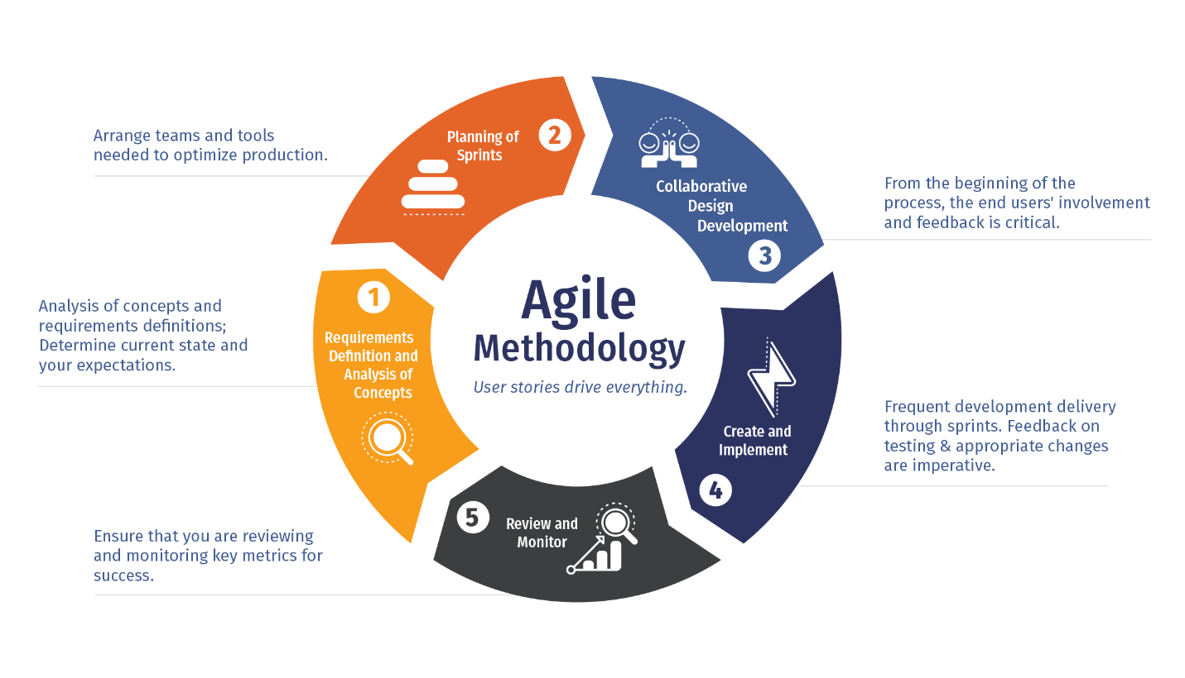
Figure 2.1 Agile Methodology

According to Figure 2.1 which shows the steps of agile methodology, it is shown that the system is builded part by part. This allows developers to deploy their system from small system to large system just like maintaining, this can help the developers to hand out the best result they can if they need to deploy their system before they finish the development.

2.3 PROJECT DURATION
The Event Management System for Kolej Tun Razak aims to streamline event planning and organization within the college premises. The project spans a duration of 12 weeks, with activities structured into several phases: Requirements Analysis, System Design, Implementation and Unit Testing, System Testing, and Maintenance.

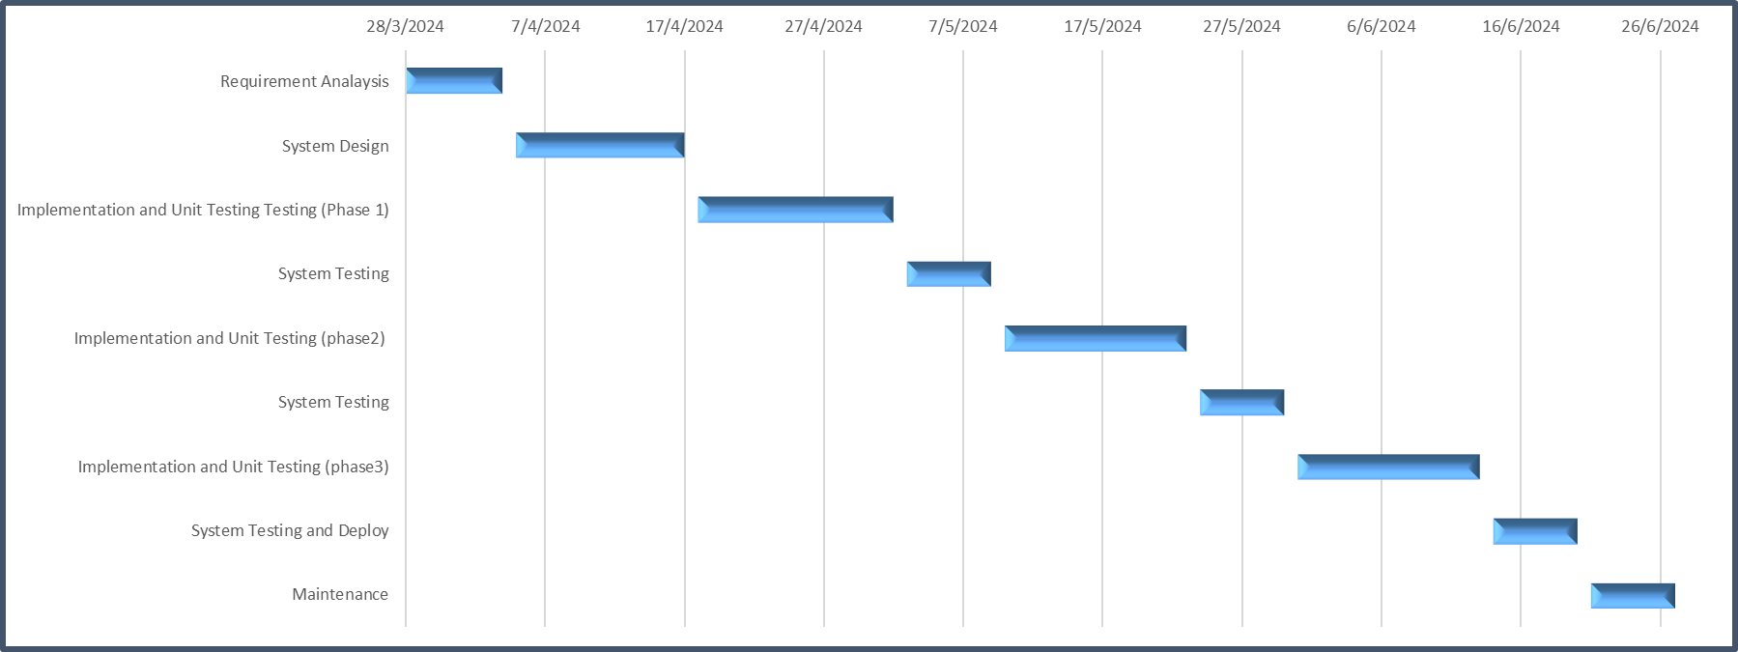
Figure 2.2 Gantt Chart

Task | Start Date | End Date | Duration
Requirement Analysis | 28/3/2024 | 4/4/2024 | 7
System Design | 5/4/2024 | 17/4/2024 | 12
Implementation and Unit Testing Testing (Phase 1) | 18/4/2024 | 2/5/2024 | 14
System Testing | 3/5/2024 | 9/5/2024 | 6
Implementation and Unit Testing (phase2) | 10/5/2024 | 23/5/2024 | 13
System Testing | 24/5/2024 | 30/5/2024 | 6
Implementation and Unit Testing (phase3) | 31/5/2024 | 13/6/2024 | 13
System Testing and Deploy | 14/6/2024 | 20/6/2024 | 6
Maintenance | 21/6/2024 | 27/6/2024 | 6

Table 2.3 Project Duration Table

During the first week, the project commences with Requirements Analysis, focusing on gathering and analyzing the needs of Kolej Tun Razak for the event management system. This phase culminates in the creation of the Systems Requirements Specifications document.

Following Requirements Analysis, the project progresses to System Design, divided into two phases. Phase 1 involves creating all the CSS, HTML components, and basic functionalities such as login, sign-in, and logout. Phase 2 focuses on implementing Create, Read, Update, and Delete (CRUD) functions to manage event data effectively. The Software Design Document is updated at the completion of each design phase.

Implementation and Unit Testing then ensue, with Phase 1 lasting from mid-April to early May. This phase involves translating the system design into functional code, including CSS, HTML, and basic functionalities for user authentication. Unit tests are conducted to ensure these components function correctly.

System Testing follows, spanning early to mid-May, wherein the integrated system is thoroughly tested for functionality and compliance with requirements. A System Testing Document is generated to support this phase.

Phase 2 of Implementation and Unit Testing takes place from mid to late May, focusing on implementing and testing the CRUD functionalities for managing event data.

The project concludes with a final round of System Testing and Deployment, ensuring the system is ready for use by organizers and administrators of Kolej Tun Razak. Maintenance activities then commence to support ongoing system functionality and performance, ensuring the successful development and operation of the Event Management System. Any further enhancements are addressed in Phase 3, contingent upon the smooth operation of the system.

REFERENCES
Destiny Blog : https://youngdestinya.ng/agile-approach-to-business-growth-sending-it-on-an-errand/

